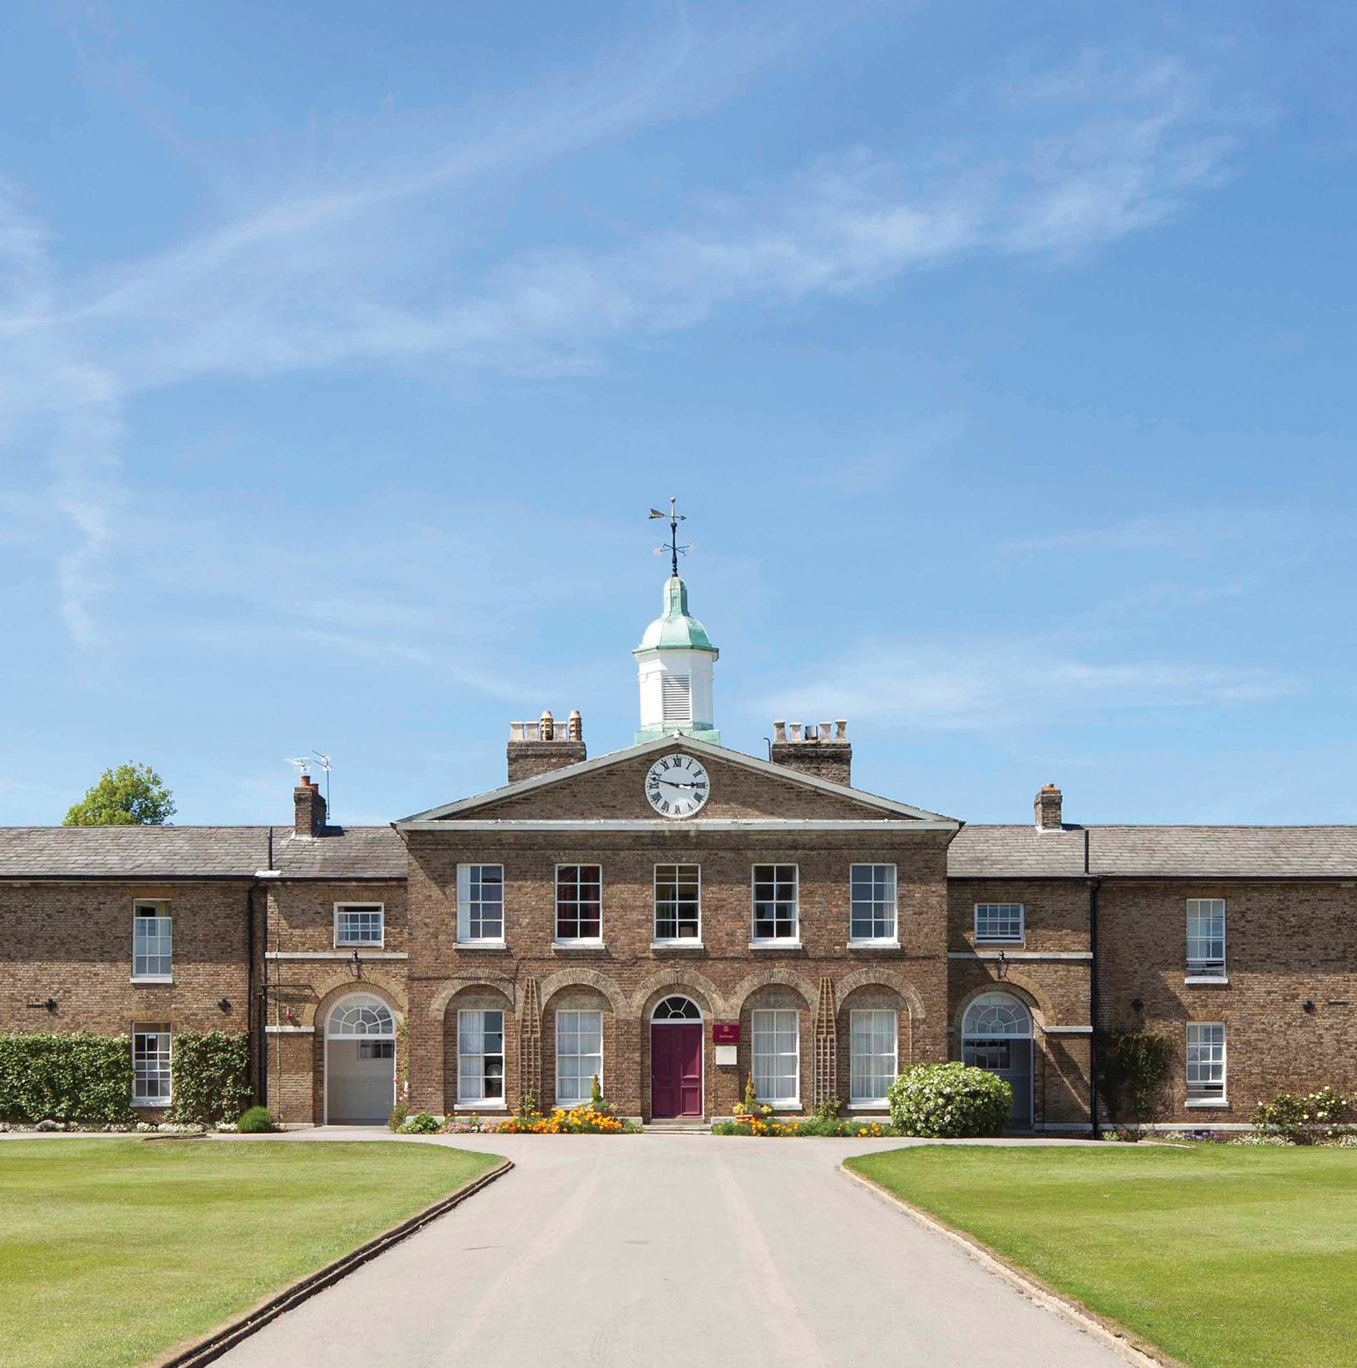
Candidate brief
Chemistry Teacher (Maternity Cover)
From January 2021
Published: 29 September 2020
Application deadline: 6 October 2020

Founded in 1862, Haileybury is a school that is rooted in history and tradition; however,
it is also an innovative, progressive institution that seeks to provide the best possible education for all of our boys and girls. Pupils here are known and valued and are supported along their own
pathways. We are an outward-facing institution, underpinned by values built on service and humility.

Pastoral care at Haileybury is at the centre of everything we do. Our aim is to nurture and support our pupils, educating and guiding them so that they leave Haileybury as rounded, balanced, decent human beings. We hope that our girls and boys will give more to the world than they take, who understand the importance of kindness, service and humanity, who dream with their eyes wide open and who are ready to face whatever challenges life throws at them.

Haileybury is a beautiful school with fantastic grounds and buildings. The atmosphere is calm and purposeful. At the heart of it all are the people: the pupils, staff, parents and governors, all of whom want the very best for each individual within our community.

The academic provision at Haileybury seeks to develop learners who are academically ambitious, intellectually curious, imaginative and independent. We want our pupils to acquire the skills, knowledge and understanding that they will need to make the world a better place, and
the sense of responsibility and compassion required to do so. We believe in offering pupils flexibility and choice in a progressive context; they are encouraged to follow their personalised pathways.

Our curriculum is evolving: it is innovative and progressive. It will require learning to be more fluid, collaborative, research-driven and connected.

The outstanding co-curricular offer at Haileybury provides both breadth, in terms of opportunity, and depth in terms of specialist provision. By supporting them through challenging experiences in the co-curriculum, we believe pupils develop character, confidence and a sense of identity. Equally, we want our pupils to enjoy their co-curricular experiences and to find fulfilment from developing new skills and achieving goals.

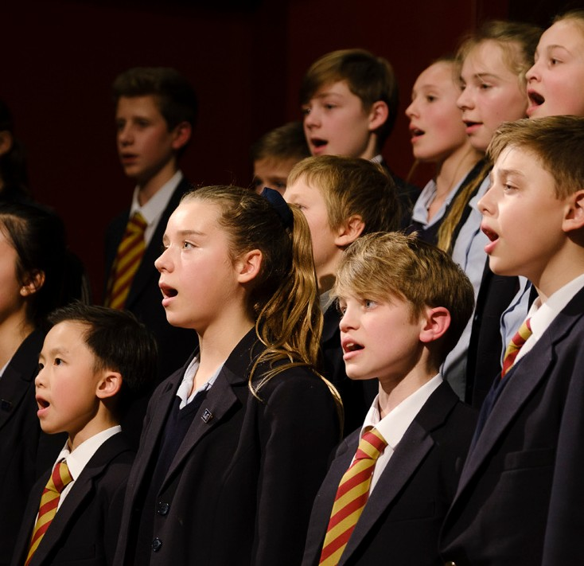

The role

The Chemistry Department

An opportunity has arisen for a talented, innovative and inspirational teacher of chemistry to join the Chemistry department at Haileybury. There is a vibrant, collaborative spirit within the department and its 6 full-time teachers with a wide range of interests give it real strength. The ideal candidate is someone with high professional standards, enthusiasm, energy and a clear sense of teamwork. They also need to demonstrate a real passion for the subject, and have the ability to convey this to the pupils. The applicant will be expected to fulfil the teaching requirements as directed by the Head of Department, according to the overall aims of the School. The teacher can expect to teach classes from Lower School 1 (Year 7) to the Upper Sixth (Year 13).

At Haileybury, Students in the lower school (years 7-8) follow a co0ordinated science programme with teachers taking their groups through all three disciplines on rotation. Students in the middle school follow the Edexcel iGCSE course. Teachers are able to get to know there students well, often taking a group through both Middles (Year 10) and Fifths (Year 11). In the Sixth Form students can choose between the OCR A-level Chemistry or the International Baccalaureate Diploma Programme (IBDP). In the IBDP, Chemistry is offered at both Higher and Standard level, providing a challenging course with an individual investigative project forming 20% of the course. We offer students the chance to get involved in national competitions such as Top of the Bench and the Salters Chemistry Festival and regularly have a good number of keen students working on the RSC’s Olympiad. It is expected, therefore, that the postholder will encourage, nurture and develop pupils outside of formal lesson time as well as during timetabled lessons.

The Chemistry department is a well-equipped, bright building, which had a considerable refurbishment in the summer of 2018, and all laboratories are of a high specification. There is also a science lecture theatre and a discovery room creating an attractive teaching environment. The department is very well supported by two dedicated lab technicians which enables us to incorporate a significant level of practical work and demonstrations into our teaching which we believe strongly enhances students experiences.

The teacher will also be expected to offer support to the learning, pastoral and co-curricular needs of the individual students through the House system as a tutor and the co-curricular programme. It is expected that these duties will be carried out to a high standard to ensure the all-round quality of education for pupils at Haileybury.

Key responsibilities

All professional duties are outlined in the Contract of Employment, the associated Employment Manual and the Staff Handbook. Here is an extract of the key responsibilities and tasks:

- Ensure the best possible academic outcomes for pupils through planning, preparing and delivering courses and lessons to a high standard.
- Assess, mark, record and report on the development, progress and attainment of pupils in line with School and Departmental policy.
- Provide timely and supportive feedback to pupils on their work following the agreed policies in the Staff and Departmental Handbooks with regard to such matters as programmes of study, teaching methods, supporting pupils with Learning Support needs and homework (prep).
- Maintain a stimulating teaching environment and exercise proper care of teaching materials, equipment and rooms.
- Advise on and co-operate in the preparation and development of appropriately board, balanced and relevant courses of study, teaching materials, teaching programmes, methods of teaching and assessment.
- Promote the general progress and well-being of individual pupils and groups of pupils.
- Participate in arrangements for further external training and professional development as a teacher.
- Work with and inspire a tutor group of young people, as part of a wider team of year group and boarding house tutors following the expectations set out in the Staff Handbook.
- Maintain good order and discipline among the pupils and safeguard their health and safety

Benefits package Equal Opportunities

The salary will be commensurate with the experience of the post holder.
All members of the teaching staff receive access to private health care and receive subsidised school fees for children, provided entrance requirements are met.
Over 90% of our teaching staff live on site and have the cost of their Council Tax covered: those who do not will receive a living out allowance to cover the costs of accommodation.

The Common Room is welcoming and staff wellbeing is prioritised; the school has a full-time Health Centre as well as a resident Church of England Chaplain.

Haileybury is an equal opportunities employer and is committed to a policy of treating all our employees and job applicants equally. It is our policy to take all reasonable steps to employ and promote employees on the basis of their abilities and qualifications without regard to age, disability, sex, gender reassignment, pregnancy, maternity, marital or civil partnership status, race (which includes colour, nationality and ethnic or national origins), sexual orientation, trade union membership, religion or belief.

Travelling to Haileybury

Air
London Heathrow (50 minutes by car), London Stansted (30 minutes by car) and London Luton (40 minutes by car) airports are within easy reach of Haileybury. London Gatwick Airport (75 minutes by car) is only slightly further away. All are served by rail links to central London.

Rail
There are two main line railway stations close to Haileybury. Hertford North to London (Moorgate or King’s Cross) is a 40-minute journey. Broxbourne to London (Liverpool Street) is 35 minutes. Hertford North is a five minute car ride from Haileybury and Broxbourne is 10 minutes away.

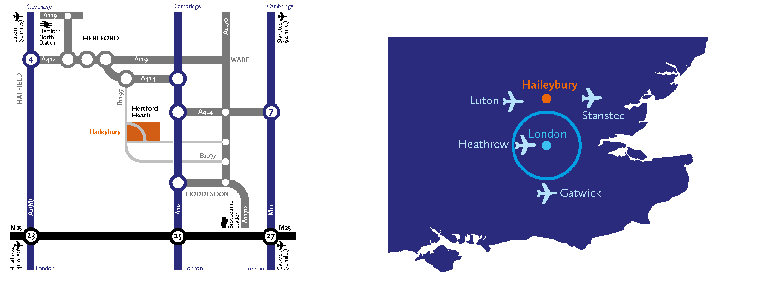
Road
Haileybury is conveniently located close to the A10 and easily accessible via the M25, A1(M), M11 and A414.
- From the South East: Leave the M25 at junction 25 to join the A10 north (Cambridge), exiting the A10 at Hoddesdon.
- From the South West: Leave the M25 at junction 21a to join the A405, then the A414 to Hatfield and on to Hertford. The B1197 leads to Hertford Heath village.
- From the North: Leave the A1(M) at junction 4 for the A414 to Hertford, or leave the M1 at junction 7 (St Albans) for the A414 to Hertford.
- From the East: Via the M11 leave at junction 7 (Harlow) for the A414 to Hertford.

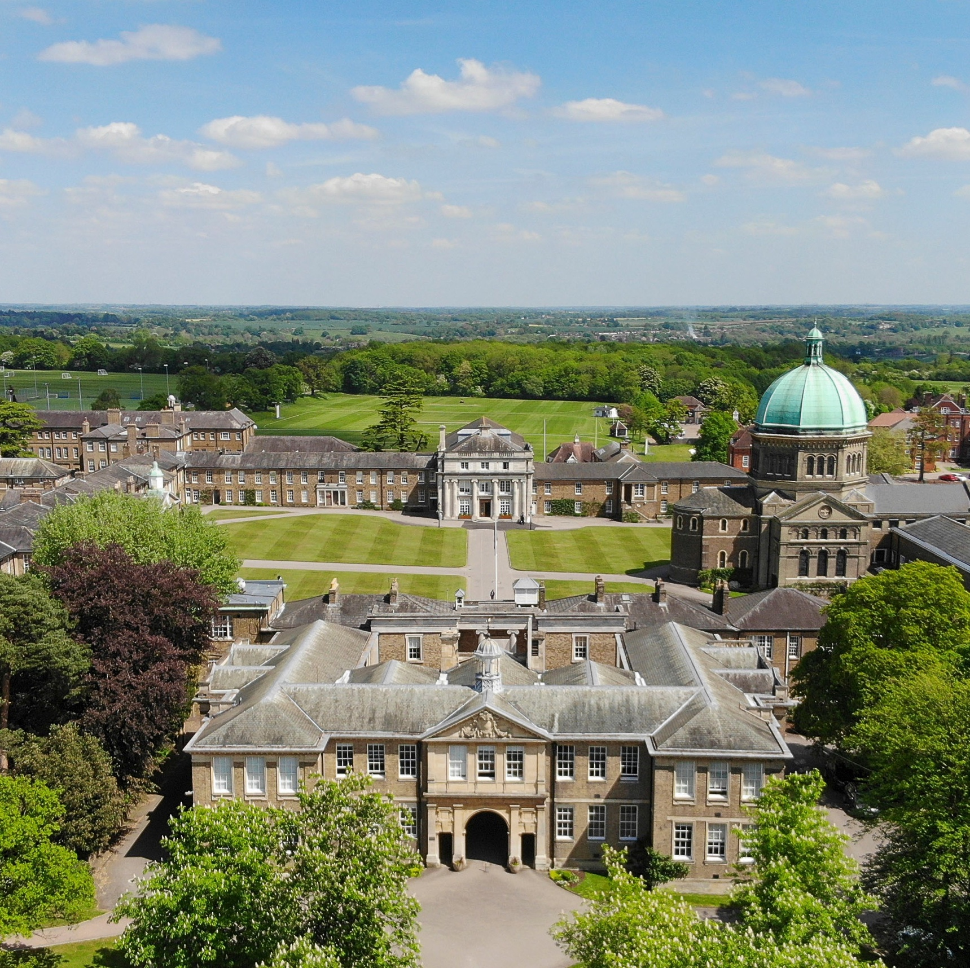
HaileyburyUK
01992 706 200 haileybury.com Hertford Herts SG13 7NU Registered charity number 310013

