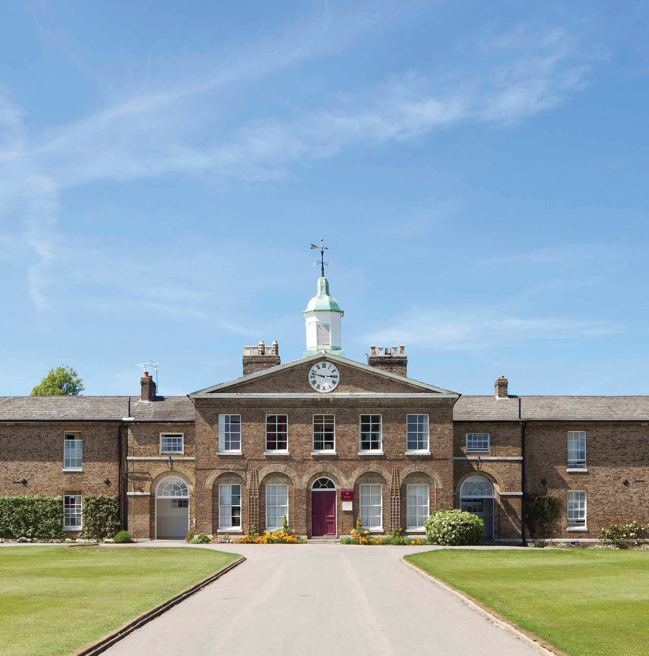
Candidate brief
Maths Teacher (from September 2020)
Published: Thursday 14 May 2020
Application deadline: 12pm Wednesday 20 May 2020

Founded in 1862, Haileybury is a school that is rooted in history and tradition; however,
it is also an innovative, progressive institution that seeks to provide the best possible education for all of our boys and girls. Pupils here are known and valued and are supported along their own
pathways. We are an outward-facing institution, underpinned by values built on service and humility.

Pastoral care at Haileybury is at the centre of everything we do. Our aim is to nurture and support our pupils, educating and guiding them so that they leave Haileybury as rounded, balanced, decent human beings. We hope that our girls and boys will give more to the world than they take, who understand the importance of kindness, service and humanity, who dream with their eyes wide open and who are ready to face whatever challenges life throws at them.

Haileybury is a beautiful school with fantastic grounds and buildings. The atmosphere is calm and purposeful. At the heart of it all are the people: the pupils, staff, parents and governors, all of whom want the very best for each individual within our community.

The academic provision at Haileybury seeks to develop learners who are academically ambitious, intellectually curious, imaginative and independent. We want our pupils to acquire the skills, knowledge and understanding that they will need to make the world a better place, and
the sense of responsibility and compassion required to do so. We believe in offering pupils flexibility and choice in a progressive context; they are encouraged to follow their personalised pathways.

Our curriculum is evolving: it is innovative and progressive. It will require learning to be more fluid, collaborative, research-driven and connected.

The outstanding co-curricular offer at Haileybury provides both breadth, in terms of opportunity, and depth in terms of specialist provision. By supporting them through challenging experiences in the co-curriculum, we believe pupils develop character, confidence and a sense of identity. Equally, we want our pupils to enjoy their co-curricular experiences and to find fulfilment from developing new skills and achieving goals.

The role

The Maths Department

An opportunity has arisen to join an outstanding Maths department. Maths is the most popular subject at Haileybury and has an impressive track record when it comes to Public Exam results. The current department is a large, strong team with an excellent blend of youth and experience. Within the department we strive to engage young people and inspire them with a love of the subject. We believe in prioritising understanding ahead of learning and so encourage pupils at all ages to be able to articulate the logic that underpins the methods that they use.

The school is looking for a dynamic and committed teacher to teach from Lower School 1 through to the Upper Sixth. The Lower School pupils (Years 7 and 8) follow a course that resembles the Common Entrance syllabus. In Removes (Year 9) our pupils commence on a three year International GCSE course (iGCSE). Pupils from the top sets also have the option of sitting Further Maths GCSE. All pupils taking the IB Diploma study Maths in the Sixth Form, choosing either the Applications and Interpretation course, or the Analysis and Approaches course. Maths is also the most popular A Level option with good numbers also opting for Further Maths each year. For most members of the department, Sixth Form teaching occupies half their timetable.

The department has use of a dedicated building on the campus. There are ten classrooms as well as a Sixth Form study room and a departmental office in the building. All classrooms are equipped with interactive whiteboards and Apple TV to allow teachers to make use of their school-issued iPads in their teaching if they wish.

Outside the main curriculum, the department staff a daily workshop each afternoon, which attracts a large number of pupils who are keen to take advantage of the extra help on offer. This is one way in which we aim to foster a culture of supported independent study. In addition, there is a newly started (pupil-led) Maths society, which meets each fortnight. A love of the subject is promoted as pupils take turns to present on different areas of interest and discuss questions that are raised off the back of this. We also enter a large number of pupils into the UKMT challenges each year with pupils regularly qualifying for follow-on rounds. We run our own “House Maths” competition and also enter pupils into external team challenges with fierce competition for places in the squads.

Key responsibilities

- Ensure the best possible academic outcomes for pupils through planning, preparing and delivering courses and lessons to a high standard.

- Assess, mark, record and report on the development, progress and attainment of pupils in line with College and Departmental policy; providing timely and supportive feedback to pupils on their work following the agreed policies in the Staff and Departmental Handbooks with regard to such matters as programmes of study, teaching methods, supporting pupils with Learning Support needs and homework (prep).

- Maintain a stimulating teaching environment and exercise proper care of teaching materials, equipment and rooms.

- Advise on and co-operate in the preparation and development of courses of study, teaching materials, teaching programmes, methods of teaching and assessment.

- Promote the general progress and well-being of individual pupils and groups of pupils.

- Participate in arrangements for further external training and professional development as a teacher.

- Work with and inspire a tutor group of young people, as part of a wider team of year group and boarding house tutors following the expectations set out in the Staff Handbook.

- Supervise pupils as part of a boarding house tutor team; this will include carrying out an evening boarding house duty, and occasional Saturday evening and Sunday commitments.

- Share responsibility for all pupils within the College (especially those in your teaching or tutor groups) in liaison with appropriate Heads of Department, Housemasters and Housemistresses and senior managers.

- Maintain good order and discipline among the pupils and safeguard their health and safety both when they are on the College premises and when they are engaged in College activities elsewhere.

Benefits package Equal Opportunities

The salary will be commensurate with the experience of the post holder.
All members of the teaching staff receive access to private health care and receive subsidised school fees for children, provided entrance requirements are met.
Over 90% of our teaching staff live on site and have the cost of their Council Tax covered: those who do not will receive a living out allowance to cover the costs of accommodation.

The Common Room is welcoming and staff wellbeing is prioritised; the school has a full-time Health Centre as well as a resident Church of England Chaplain.

Haileybury is an equal opportunities employer and is committed to a policy of treating all our employees and job applicants equally. It is our policy to take all reasonable steps to employ and promote employees on the basis of their abilities and qualifications without regard to age, disability, sex, gender reassignment, pregnancy, maternity, marital or civil partnership status, race (which includes colour, nationality and ethnic or national origins), sexual orientation, trade union membership, religion or belief.

Travelling to Haileybury

Air
London Heathrow (50 minutes by car), London Stansted (30 minutes by car) and London Luton (40 minutes by car) airports are within easy reach of Haileybury. London Gatwick Airport (75 minutes by car) is only slightly further away. All are served by rail links to central London.

Rail
There are two main line railway stations close to Haileybury. Hertford North to London (Moorgate or King’s Cross) is a 40-minute journey. Broxbourne to London (Liverpool Street) is 35 minutes. Hertford North is a five minute car ride from Haileybury and Broxbourne is 10 minutes away.

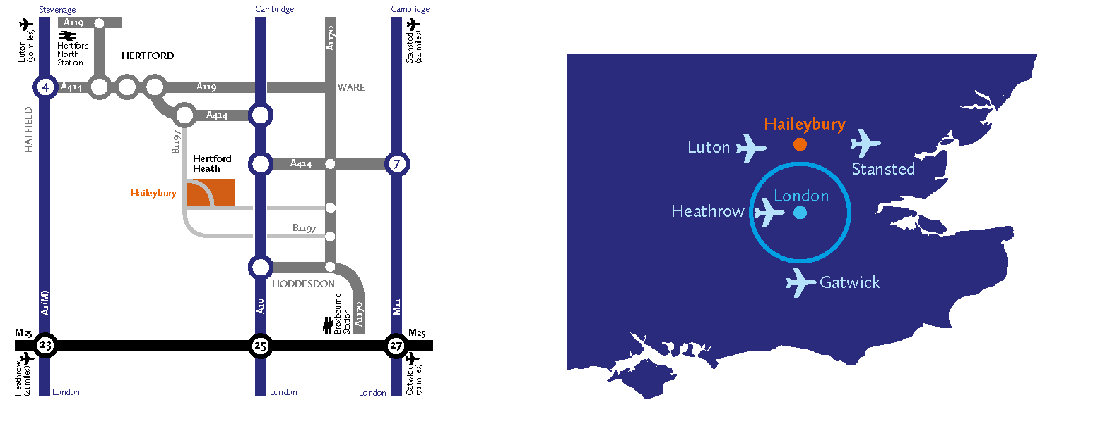
Road
Haileybury is conveniently located close to the A10 and easily accessible via the M25, A1(M), M11 and A414.
- From the South East: Leave the M25 at junction 25 to join the A10 north (Cambridge), exiting the A10 at Hoddesdon.
- From the South West: Leave the M25 at junction 21a to join the A405, then the A414 to Hatfield and on to Hertford. The B1197 leads to Hertford Heath village.
- From the North: Leave the A1(M) at junction 4 for the A414 to Hertford, or leave the M1 at junction 7 (St Albans) for the A414 to Hertford.
- From the East: Via the M11 leave at junction 7 (Harlow) for the A414 to Hertford.

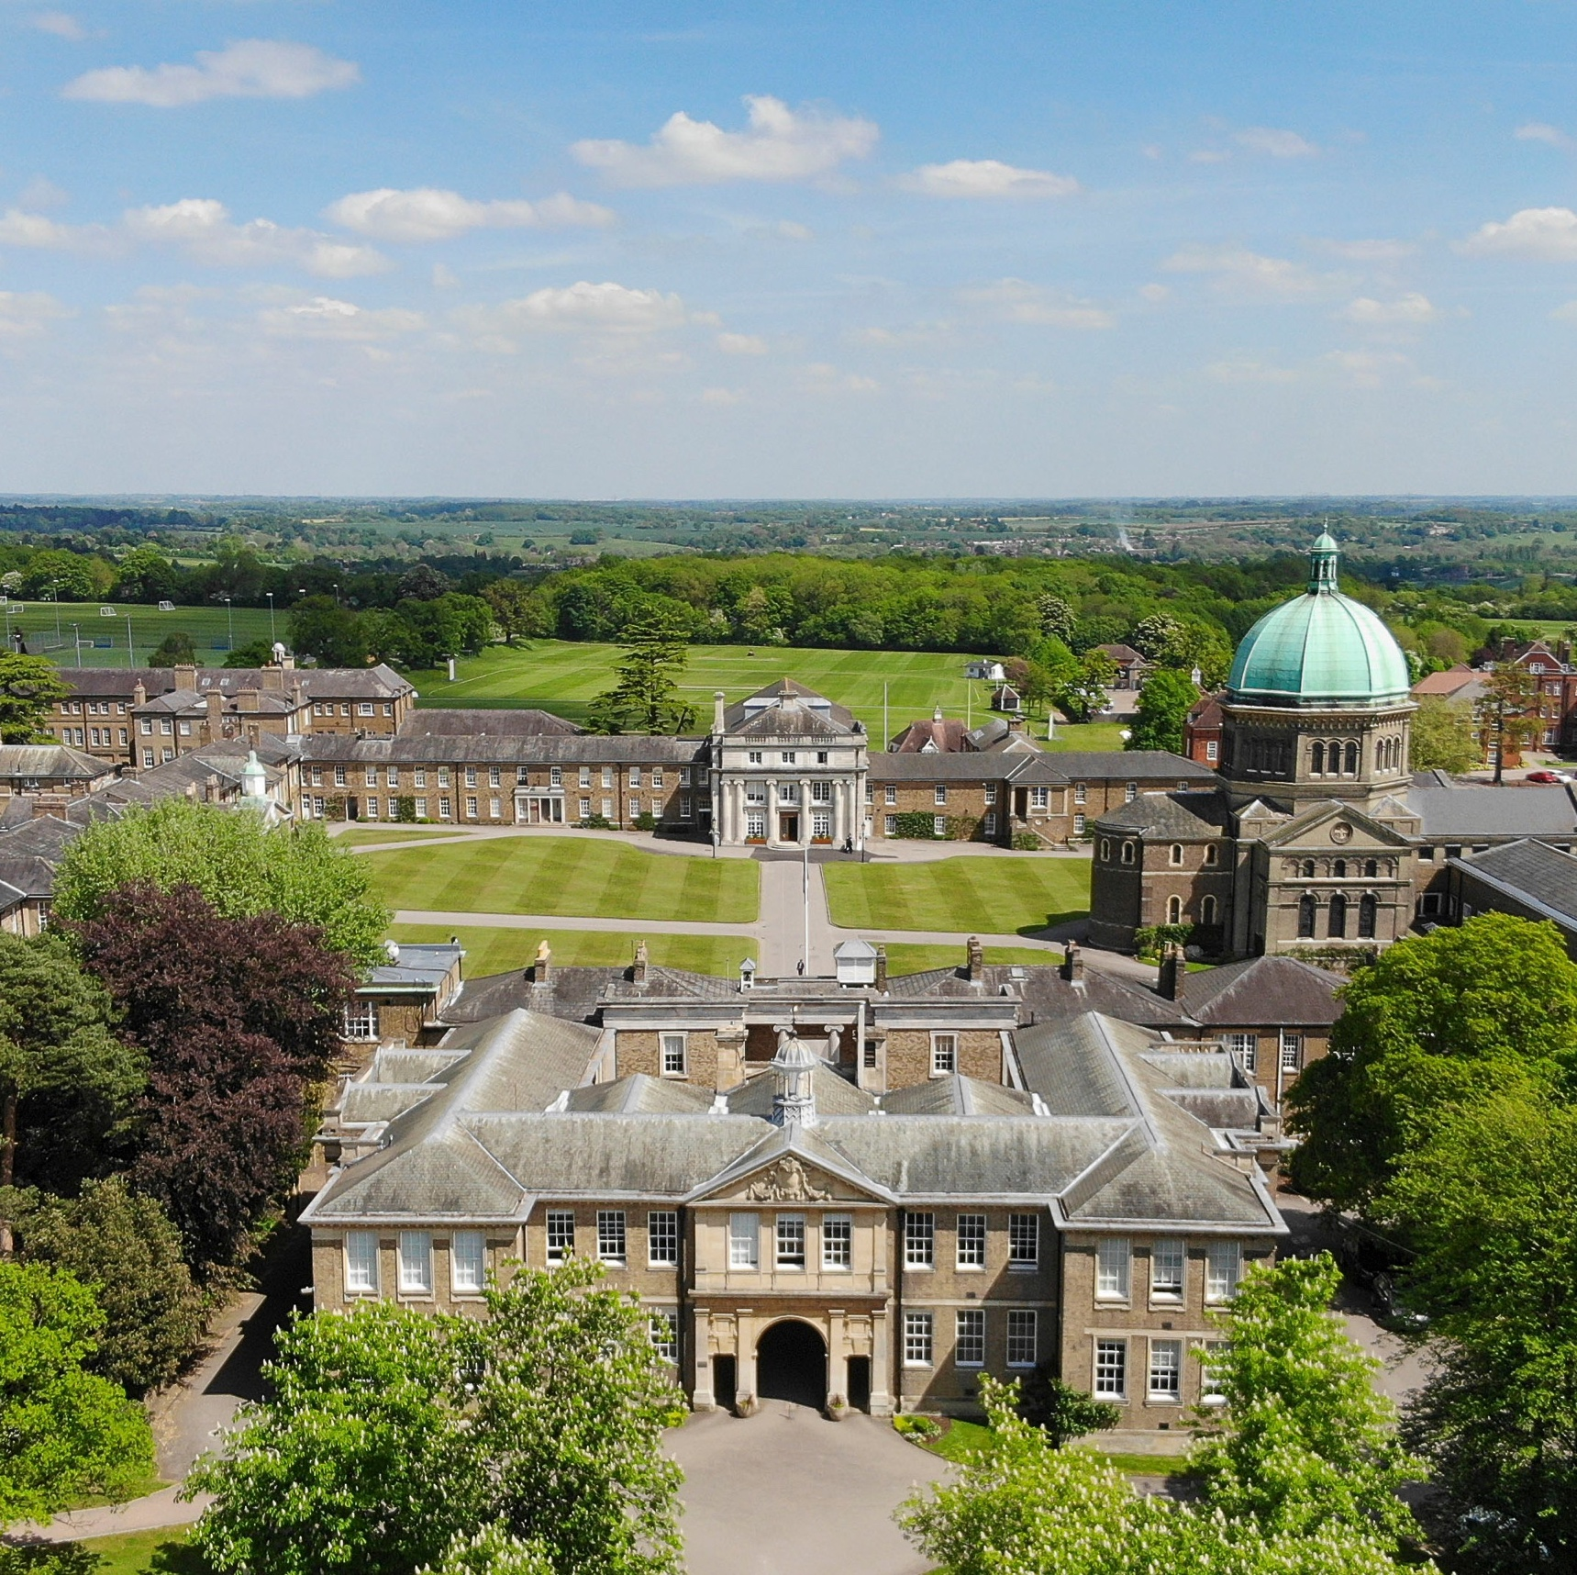
HaileyburyUK
01992 706 200 haileybury.com Hertford Herts SG13 7NU Registered charity number 310013

