Published:

Application deadline:

Candidate brief

Physics Teacher

(from September 2020)

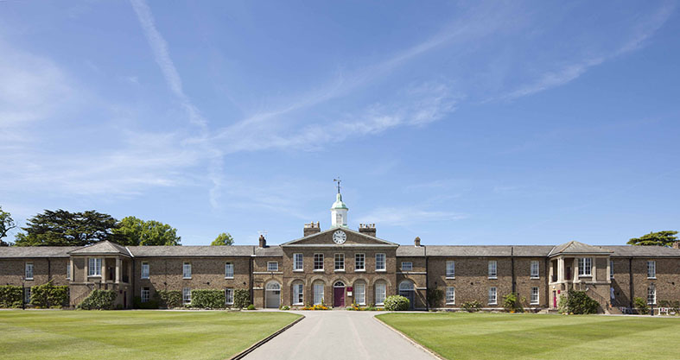



Haileybury

*Education is the leading of humans to what is best, and making what is best out of them. It is the glorious sense of the possible.*

*Founded in 1862, Haileybury is a school that is rooted in history and tradition; however, it is also an innovative, progressive institution that seeks to provide the best possible education for all of our boys and girls. Pupils here are known and valued and are supported along their own pathways. We are an outward-facing institution, underpinned by values built on service and humility.*

## Pastoral care at Haileybury is at the centre of everything we do. Our aim is to nurture and support our pupils, educating and guiding them so that they leave Haileybury as rounded, balanced, decent human beings who will give more to the world than they take, who understand the importance of kindness, service and humanity, who dream with their eyes wide open and who are ready to face whatever challenges life throws at them.

Haileybury is a beautiful school with fantastic grounds and buildings. It is calm and purposeful, ambitious and professional. At the heart of it all are the people: The pupils, staff, parents and governors; all of whom want the very best for each individual within our community.

The academic provision at Haileybury seeks to develop learners who are academically ambitious, intellectually curious,  imaginative and independent. We want our pupils to acquire the skills, knowledge and understanding that they will need to make the world a better place, and the sense of responsibility and compassion required to do so. We believe in offering pupils flexibility and choice in a progressive context; they are encouraged to follow their personalised pathways.

Our curriculum is evolving: it is innovative and progressive. It will require learning to be more fluid, collaborative, research-driven and connected.

The co-curricular offer at Haileybury provides both breadth, in terms of opportunity, and depth in terms of specialist provision. By supporting them through challenging experiences in the co-curriculum, we believe pupils develop character, confidence and a sense of identity. Equally, we want our pupils to enjoy their co-curricular experiences and to find fulfilment from developing new skills and achieving goals.

The role

Haileybury wishes to appoint a dynamic, innovative teacher of physics.

**Purpose of the position**

To fulfil the teaching requirements as directed by the Head of Department, according to the overall aims of the school. The teacher must be able to teach Physics in the Sixth Form (to IB Diploma and A Level), and can expect to teach classes ranging from Year 7 to Year 13.

To offer support to the learning, pastoral and co-curricular needs of the individual students through the house system as a tutor and the co-curricular programme. These duties should be carried out to a high standard to ensure the all-round quality of education for pupils at Haileybury.

All professional duties are outlined in the Contract of Employment, the associated Employment Manual and the Staff Handbook. Here is an extract of the key responsibilities and tasks:

**Key responsibilities**

* Ensure the best possible academic outcomes for pupils through planning, preparing and delivering courses and lessons to a high standard.
* Assess, mark, record and report on the development, progress and attainment of pupils in line with College and Departmental policy; providing timely and supportive feedback to pupils on their work following the agreed policies in the Staff and Departmental Handbooks with regard to such matters as programmes of study, teaching methods, supporting pupils with Learning Support needs and homework (prep).
* Maintain a stimulating teaching environment and exercise proper care of teaching materials, equipment and rooms.
* Advise on and co-operate in the preparation and development of courses of study, teaching materials, teaching programmes, methods of teaching and assessment.
* Promote the general progress and well-being of individual pupils and groups of pupils.
* Participate in arrangements for further external training and professional development as a teacher.
* Work with and inspire a tutor group of young people, as part of a wider team of year group and boarding house tutors following the expectations set out in the Staff Handbook.
* Supervise pupils as part of a boarding house tutor team; this will include carrying out an evening boarding house duty, and occasional Saturday evening and Sunday commitments.
* Share responsibility for all pupils within the College (especially those in your teaching or tutor groups) in liaison with appropriate Heads of Department, Housemasters and Housemistresses and senior managers.
* Maintain good order and discipline among the pupils and safeguard their health and safety both when they are on the College premises and when they are engaged in College activities elsewhere.

Benefits package

* The salary will be commensurate with the experience of the appointed candidate.
* The Common Room is welcoming and you will have access to free tea and coffee throughout the working day. The school also has a resident doctor and full-time Health Centre as well as a resident Church of England Chaplain.
* The College is in a fabulous location, surrounded by Hertfordshire countryside but travelling from Haileybury is very straightforward:
  + Central London is 35 minutes away by train (via Broxbourne station).
  + Cambridge is 50 minutes away by car.
  + London Stansted Airport is just 30 minutes away by car.
  + London Heathrow Airport is 50 minutes away by car.
  + London Luton Airport is just 40 minutes away by car
  + Key routes north and east/west, the A1 and M25 are 20 minutes away by car.

Equal Opportunities

Haileybury is an equal opportunities employer and is committed to a policy of treating all our employees and job applicants equally. It is our policy to take all reasonable steps to employ and promote employees on the basis of their abilities and qualifications without regard to age, disability, sex, gender reassignment, pregnancy, maternity, marital or civil partnership status, race (which includes colour, nationality and ethnic or national origins), sexual orientation, trade union membership, religion or belief.

Travelling to Haileybury

Haileybury is located in rural Hertfordshire between Hertford and Hoddesdon about 20 miles north of

central London

Air travel: London Heathrow (50 minutes by car), London Stansted (30 minutes by car) and London Luton (40 minutes by car) airports are within easy reach of Haileybury. London Gatwick Airport (75 minutes by car) is only slightly further away. All are served by rail links to central London.

By rail: There are two main line railway stations close to Haileybury. Hertford North to London (Moorgate or King’s Cross) is a 40-minute journey. Broxbourne to London (Liverpool Street) is 35 minutes. Hertford North is a five minute car ride from Haileybury and Broxbourne is 10 minutes away.

By road: Haileybury is conveniently located close to the A10 and easily accessible via the M25, A1(M), M11 and A414.

• From the South East: Leave the M25 at junction 25 to join the A10 north (Cambridge), exiting the A10 at Hoddesdon.

• From the South West: Leave the M25 at junction 21a to join the A405, then the A414 to Hatfield and on to Hertford. The B1197 leads to Hertford Heath village.

• From the North: Leave the A1(M) at junction 4 for the A414 to Hertford, or leave the M1 at junction 7 (St Albans) for the A414 to Hertford.

• From the East: Via the M11 leave at junction 7 (Harlow) for the A414 to Hertford.

